WELLIES 4 WORK

This list was created at a Mini Conference in partnership with The European In Green Shape Project
Qualities of those who run successful home businesses:
- A good network of people who can help them- you don’t have to do everything yourself
- Create a good product/service that people want to buy! - you only have a business if you have customers
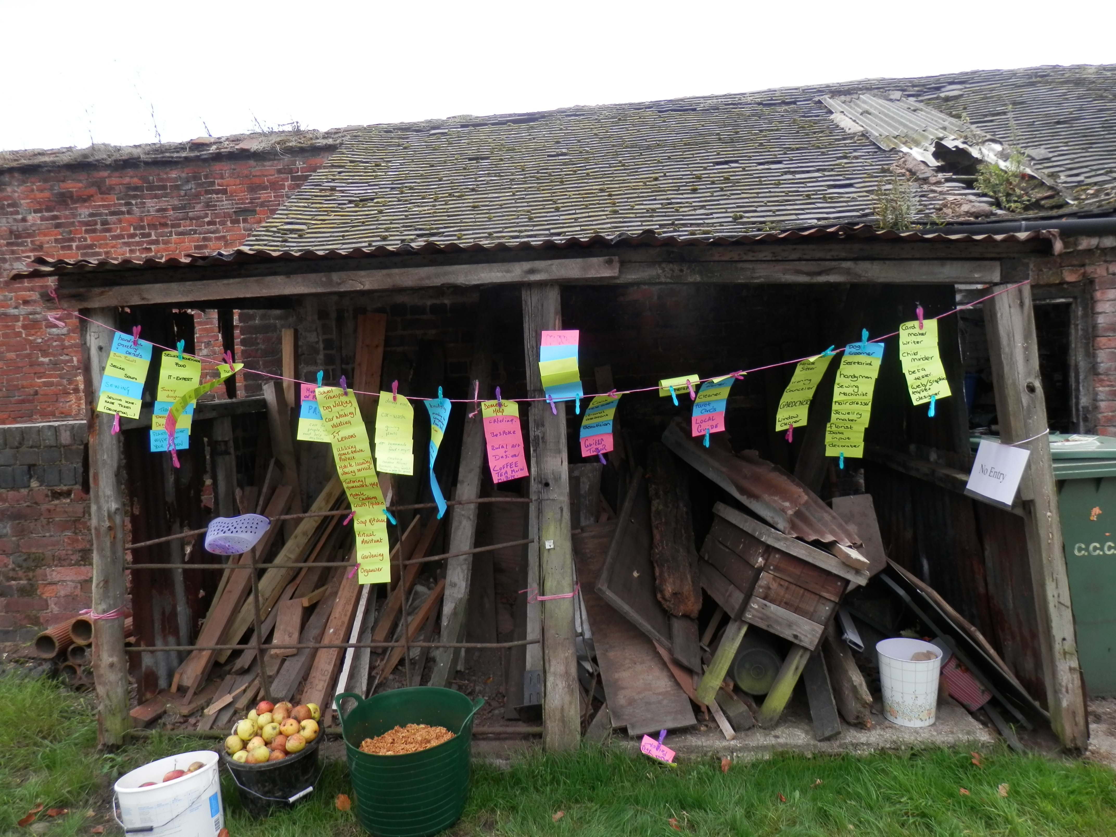
- Create Good systems and procedures – particularly financial record keeping
- Customer focused
- Determination
- Energy, drive, motivation
- Enthusiasm
- Focus
- Good Communication
- Honesty
- Integrity
- Knowledge and appropriate skills
- Organisation
- Passion
- Planning
- Resilience

